Gun Violence in the United States (2014 – 2022): Final Report
Emmanuel Jonathan
College of Business, Dallas Baptist University
MSITM-6303: Data Visualization
Dr. Samuel I. Okate
October 27, 2025

1. Introduction and Background
Gun violence remains one of the most pressing public-safety issues in the United States. Although the Second Amendment protects citizens’ right to bear arms, the rapid growth of firearm-related incidents has sparked renewed debate about safety, policy, and community well-being. According to Goldstick, Cunningham, and Carter (2022), firearm injury has become a leading cause of death among American adolescents, underscoring the urgency of addressing this crisis. Similarly, Kaufman et al. (2020) documented steady increases in both fatal and non-fatal firearm injuries between 2009 and 2017.
Our project uses data visualization to explore the geographic patterns of gun-violence incidents between 2014 and 2022. Using Tableau, we developed interactive graphics to answer three questions:
1. Which states recorded the highest per-capita gun-violence rates?
2. How have incident counts, injuries, and fatalities changed over time?
3. What does the composition of harm (injuries vs. fatalities) reveal about the human cost of gun violence?
By visualizing credible datasets, we aimed to transform complex data into an accessible narrative that can inform policymakers and communities.

2. Datasets and Methodology
Data were obtained from the Kaggle dataset Gun Violence Incidents in the USA (Fwerr, 2023). The dataset contains 3,609 records with seven variables: Incident ID, Incident Date, State, City, Address, # Killed, and # Injured. These variables document mass-shooting incidents across all 50 states and the District of Columbia.
Population estimates were drawn from the U.S. Census Bureau (2022) as hosted on Kaggle. Both datasets were joined in Tableau using a Left Join on the field State. A calculated field normalized incident counts by population:
( COUNTD([Incident ID]) / SUM([Population 2022]) ) * 100000
This formula produces incident rates per 100,000 residents (Centers for Disease Control and Prevention [CDC], n.d.). Limitations include the use of 2022 population data for all years and varying reporting practices, but these datasets are widely recognized in other research works (Pew Research Center, 2023).

3. Data Story and Visualizations
The Tableau workbook includes five main components:
3.1 Geographic Distribution of Gun Violence Rates
The filled map shows per-capita gun-violence rates by state. Darker shading represents higher values, revealing clustering in the South and Mid-Atlantic. States like Louisiana and Mississippi record the highest rates (CDC, n.d.).
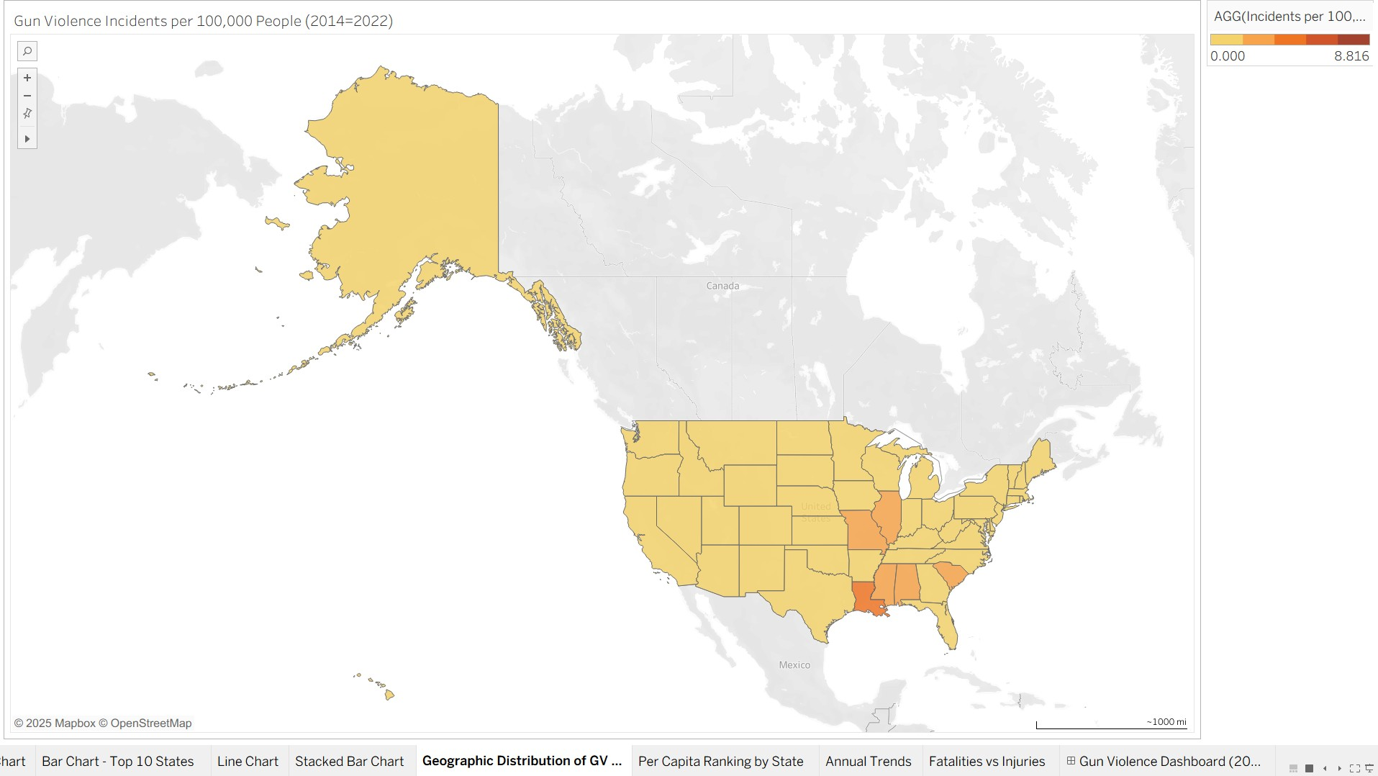
Figure 1: Geographic distribution of gun-violence rates in the United States, 2014–2022.
3.2 Per Capita Ranking by State
The horizontal bar chart ranks states by per-capita incidents. The District of Columbia leads, followed by Louisiana and Illinois. This aligns with findings by the Pew Research Center (2023).
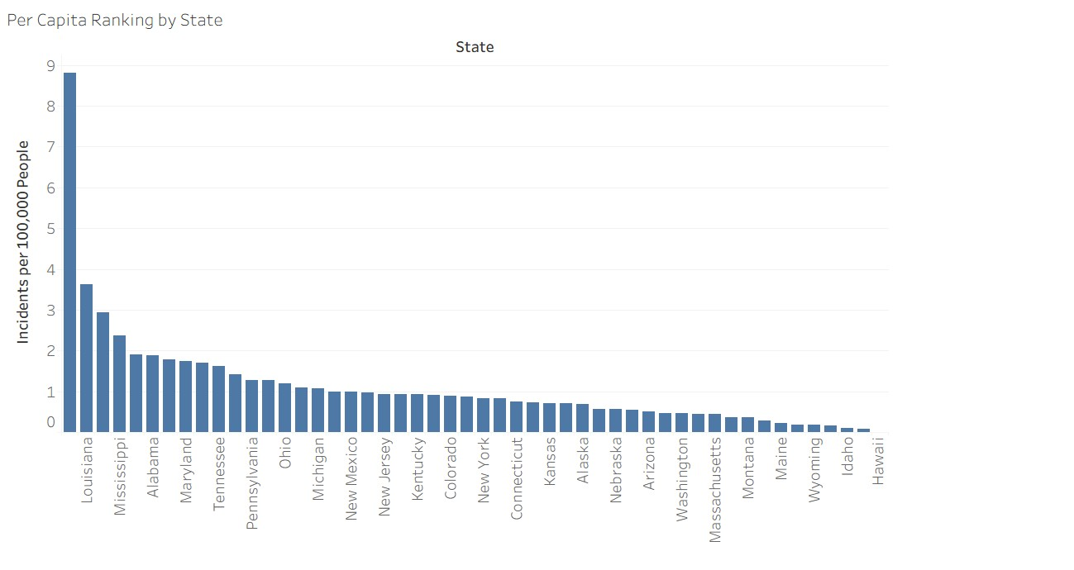
Figure 2: Per-capita ranking of U.S. states by gun-violence incidents, 2014–2022.
3.3 Annual Trends (2014 – 2022)
The line chart tracks yearly totals for incidents, injuries, and fatalities. Consistent with Kaufman et al. (2020), visualization shows a sharp increase beginning in 2019 and peaking in 2021 during the COVID-19 pandemic.
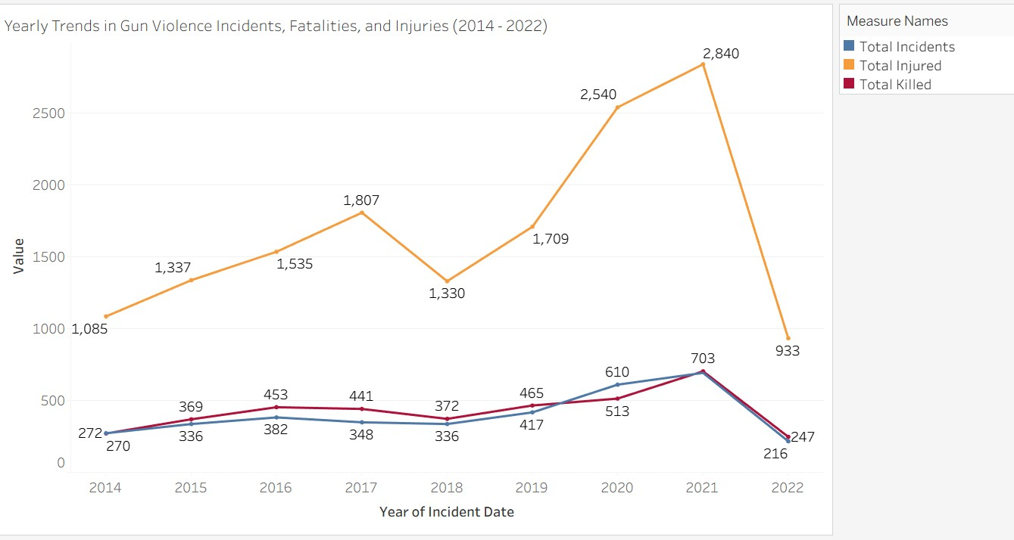
Figure 3: Annual trends in gun-violence incidents, injuries, and fatalities in the United States, 2014–2022.
3.4 Summary Table: Incidents, Injuries, and Fatalities by Year (2014 – 2022)
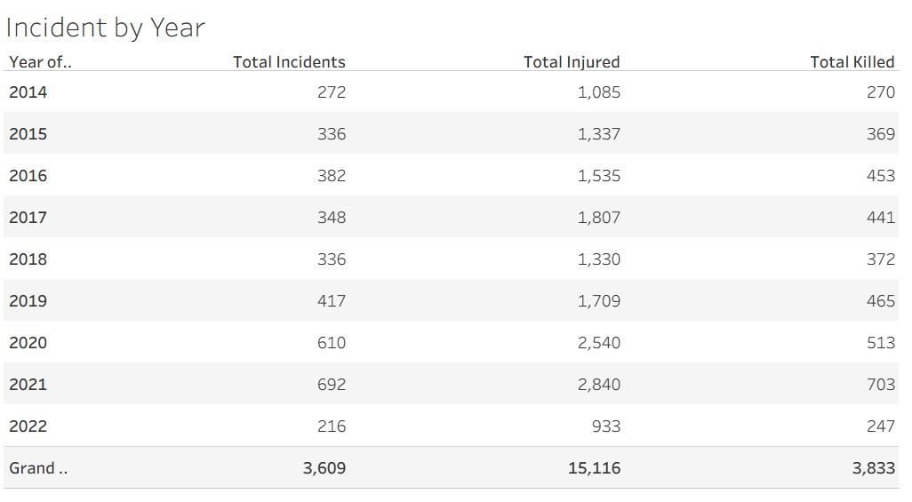
Figure4: Summary of annual totals for incidents, injuries, and fatalities.
3.5 Fatalities vs. Injuries
Stacked bars compare annual totals of injuries and fatalities. Although injuries outnumber fatalities, both trends upward, underscoring the substantial burden (Goldstick et al., 2022).
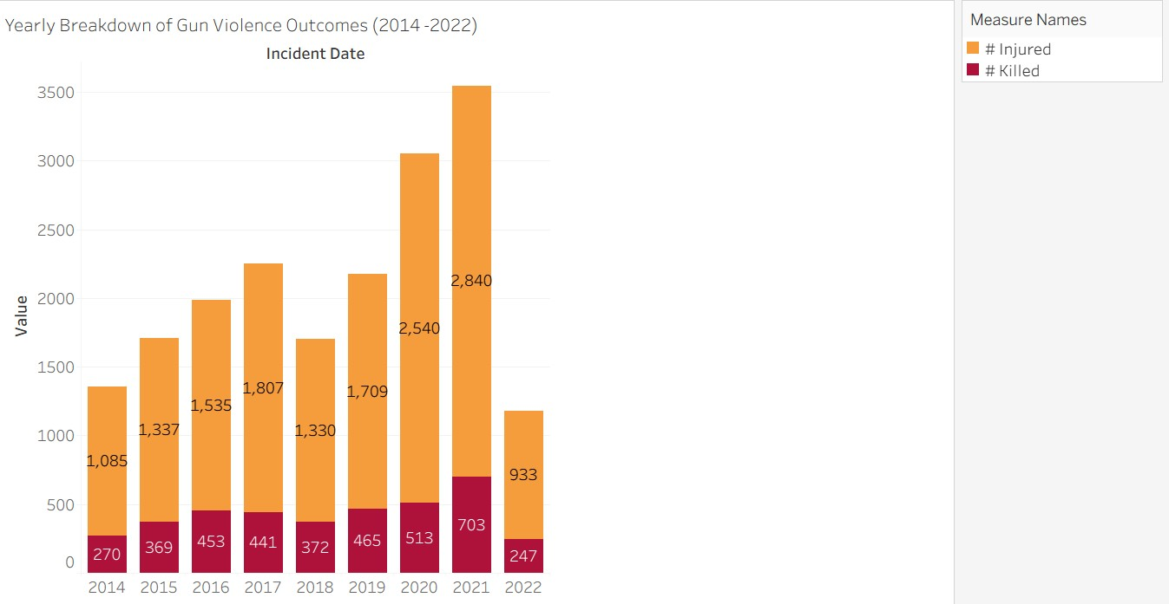
Figure 5: Comparison of fatalities and injuries from gun-violence incidents, 2014–2022.
3.6 Gun Violence Dashboard (2014 – 2022)
The interactive dashboard integrates all charts and allows users to filter by state. The design follows best practices in data storytelling (Knaflic, 2015).
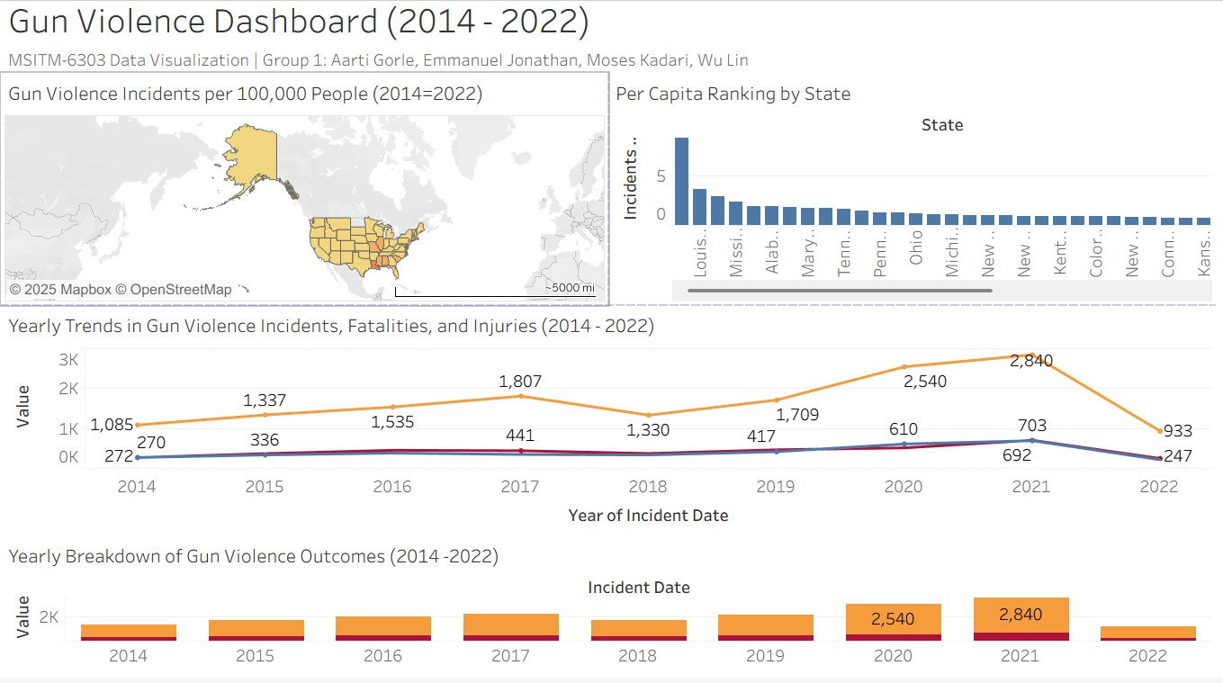
Figure 6: Interactive dashboard combining geographic, ranking, and temporal visualizations of U.S. gun-violence data, 2014–2022.

4. Summary and Conclusions
This project demonstrated how Tableau dashboards can transform data into insights. The project specifically demonstrated that gun violence in the United States displays strong geographic clustering, steady long-term growth, and significant variation in injury versus fatality outcomes. The analysis revealed persistent growth in U.S. gun-violence incidents from 2014 to 2022, with the highest per-capita rates in southern and mid-Atlantic states. Incidents, injuries, and fatalities rose sharply after 2018, peaking in 2021. Injuries consistently outnumber fatalities, showing the long-term consequences of non-fatal shootings.
5. Call to Action:
Public officials should implement targeted interventions in high-burden regions, invest in violence-prevention programs, and expand trauma and mental-health support for communities deeply affected by gun violence. Data-driven policy development is crucial to reducing firearm harm and improving public safety outcomes.

References
Centers for Disease Control and Prevention. (n.d.). Web-based Injury Statistics Query and Reporting System (WISQARS). https://www.cdc.gov/injury/wisqars
Fwerr, E. (2023). Gun violence incidents in the USA [Data set]. Kaggle. https://www.kaggle.com/datasets/emmanuelfwerr/gun-violence-incidents-in-the-usa
Goldstick, J. E., Cunningham, R. M., & Carter, P. M. (2022). Current causes of death in children and adolescents in the United States. The New England Journal of Medicine, 386(20), 1955–1956. https://doi.org/10.1056/NEJMc2201761
Kaufman, E. J., Wiebe, D. J., Xiong, R. A., Morrison, C. N., Seamon, M. J., & Delgado, M. K. (2021). Epidemiologic trends in fatal and nonfatal firearm injuries in the U.S., 2009–2017. JAMA Internal Medicine, 181(2), 237–244. https://doi.org/10.1001/jamainternmed.2020.6696
Knaflic, C. N. (2015). Storytelling with data: A data visualization guide for business professionals. Wiley.
Pew Research Center. (2023, April 26). What the data says about gun deaths in the U.S. https://www.pewresearch.org/short-reads/2023/04/26/what-the-data-says-about-gun-deaths-in-the-u-s/
U.S. Census Bureau. (2022, December 22). State population totals and components of change: 2020–2022. https://www.census.gov/data

